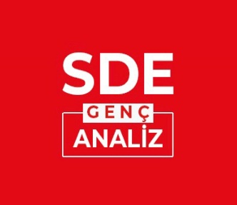

**'SDE Youth Analysis' Publication Principles and Rules**

SDE Youth Analysis is an initiative of the Institute of Strategic Thinking (SDE). The main focus of this initiative is to publish scientific works such as essays and articles with an aim to present new ideas and opinions to the readers.

SDE Youth Analysis aims to provide readers with a new vision of the future, following global political, social and intellectual developments, especially in the Islamic World, and intends to present suggestions for the resolution of existing problems.

The coordination services of SDE Youth Analysis are carried out by young researchers.

**Publication Principles**

The articles submitted for publication for this initiative shall be examined by researchers at SDE in terms of purpose, scope, content, method, and compliance with spelling rules. Articles considered technically appropriate are reviewed by an experienced editor in order to be evaluated in terms of their academic competence.

* The study, which is decided to be published, is placed in the list of publications.
* The author(s) shall be responded regarding the outcome of academic and technical examination of their work within 5 working days after the last date of submission.
* Articles submitted for evaluation at SDE Youth Analysis must not have been published before in any other journal.
* Authors shall be required to make their revisions by taking into account the feedback of the editorial board.
* The editorial board shall reserve the right to publish or to reject the submitted article.
* The published articles of the authors may be removed from publication in accordance with the decision of the editorial board.
* No royalties are paid to the authors.
* The scientific and legal responsibility of the published articles belongs to the author.
* All rights of published articles belong to SDE and its author.
* Articles published in SDE Youth Analysis cannot be quoted without showing the source.

**Author Guidelines**

The manuscript prepared according to the following spelling rules and format must be sent to the newsletter in "Word" format.

Manuscripts to be sent to SDE Youth Analysis’ should be written on A4 size white paper, with 3.5 cm margins from the top, bottom, right and left sides, at least 1.5 nk line spacing, justified, without hyphenation at the end of the line and using 12 pt "Times New Roman" font. However, the tables, figures, pictures, graphics and the like sent should not exceed the 12x17 cm area so that they do not go beyond the page dimensions of the newsletter and are easier to use. For this reason, smaller font size and single spacing can be used in tables, figures, pictures, graphics, etc. APA citation system 2nd edition should be used for footnotes and bibliography.

Submitted manuscripts should not exceed 1500 words, including appendices such as pictures, figures, maps, etc. (excluding footnotes and bibliography).

The language of SDE Youth Analysis’ is Turkish. In addition, articles in English and Arabic can be published at a rate not exceeding one-third of the articles published.

SDE uses the 6th edition of APA Citation system. The articles to be sent should be arranged according to this system.

You can review the APA Citation System at https://dergipark.org.tr/tr/download/journal-file/10990.